1) HOTEL RESERVATIONS (ON YOUR OWN) $115 Single/$125 Double
(2 night minimum) Call Holiday Inn @ (217) 328-7900 and specify "Beta Sigma Psi" group. Deadline for Hotel Reservations: OCTOBER 1, 2005
(15 Single rooms and 15 Double rooms available)
2) Football Tickets $35/Person #____ $_________
3) Luncheon/Tailgate Tickets** $35/Person #____ $_________
**See page 3 for more Details TOTAL $__________
Name______________________________
Address________________________________________
City_________________________State__________Zip___________
Phone___________________________Graduation Year___________
ORDERING DEADLINE FOR TICKETS IS OCTOBER 1, 2005
Send Reservation form and check payable to Beta Sigma Psi to:
Dale Durfey, 6541 Terrace Dr , Downers Grove, IL 60516 (630) 960-3352
Homecoming
Reservation
Form
2005
Dues
Form
Name :______________________
NOTE: Paying your dues gives you the right to vote,
hold office and to make Homecoming reservations.
Send this dues form with you check payable to:
Greg Treichler
1804 Rita Avenue
St. Charles, IL 60174

2005 Dues ($15) $______
Lifetime Member ($150) $______
Chief Illini Print ($15) $_______


Non-profit Organization
U.S. Postage
PAID
Permit No. 114
Champaign, IL 61820

Address Service Requested

Alpha Alumni News
Fall 2005

Homecoming
Vs. Penn State

October 21-23, 2005

Inside this Issue!!!
Page 1 President’s Report
Page 2 Officers
Page 3 Homecoming
Page 3 Distinguished Alumni
Page 4 Alumni Scholarship
Page 4 President’s Continued
Page 5 Miscellaneous
Page 5 Donation Form

Fall
Business Meeting

October 22, 2005
9 AM
@ the House

How Important is Beta Sigma Psi to you?

As I write this article, I am preparing for another Beta Sigma Psi Homecoming. It has been two years since I was elected to serve as President of Alpha Alumni Chapter. Much has happened, to me personally, in that two years. Since Homecoming 2003, I have changed employment three times, lived in four states, gotten married, and written many more chapters in my book of life experiences. Through all of these life changing events, there have been several important sources of consistency in my life. Naturally, my faith in Christ has kept me firmly rooted, and my family is a continual source of stability. Beyond the two items that I have mentioned, not too much remains constant in anyone’s life. However, for those reading this article, there is one more item in our lives that can offer support and help to guide us during challenging times, our bond of Brotherhood through Beta Sigma Psi.
I have always known that I found something special in the Fall of 1995 when I pledged Alpha Chapter, but I never realized how much support the brothers I came to know would provide. In my twenty-eight years of life, I have met many people, made many friends and acquaintances, but none have been as important as those connections that I made during my years in Urbana. I have gained a trusted group of close friends that I know I can depend upon during difficult times. Currently, at the beginning of the 50th Anniversary of our re-activation, the Active Chapter is facing difficult times, and they need to know that they can count on the Alumni for support. Can we join together and save Alpha Chapter?
Not too long ago, my father, who is not an Alumnus, asked me why I, along with a couple other Alumni, dedicate so much time to an organization when it appears that we do not receive as much in return. The answer, for me, was very simple, I want to give back to an organization that has given so much to me over the years, and I want to ensure a place for future generations to develop Spiritually, Scholastically, and Socially at the University of Illinois.

(Continued on Page 4)

Alumni Chapter Officers
www.geocities.com/alphaalumni

President 2003-2005
Mike Nolte
P.O. Box 294
3418 North Vine Road
Oregon, IL 61061
618.974.9375
noltemw@yahoo.com

Vice President 2003-2005
Steve Eggerding
2421 S. 11th Ave
Broadview, IL 60153
(708) 343-8520

Secretary Treasurer 2004-2006
Greg Treichler
1804 Rita Avenue
St. Charles, IL 60174
(630) 762-8575
gtreichler@financialfederal.com

Alumni Advisor 2004-2006
John Garlisch
806 S. Grove
Urbana, IL 61801
(217) 344-4152
jgarlisch@hotmail.com

Publications Editor 2003-2005
Alan Schweizer
719 N Pleasant Hill Rd
East Peoria, IL 61611
(309) 282-2333
alanschweizer@insightbb.com
Director 2004-2006
Mike Woolery
815 Greenlee Ave
Winnebago, IL 61088

Director 2004-2006
Dave Ward
P O Box 91
Hennepin, IL 61327
(815) 925-7539

Director 2003-2005
Dale Durfey
6541 Terrace
Downers Grove, IL 60516
(630) 960-3352
ddurfey@oak-brook.org

Director 2004-2005
Tim Norsen
1305 Cambridge Dr
Champaign, IL 61821
(217) 355-4731
illinifantn@illinoisalumni.org

Past President
John Schweizer
159 N 2540 E Rd
Rankin, IL 60960
(217) 397-2314
JohnWS53@aol.com

Active Chapter Officers
www.uiuc.edu/ro/betasigs

President Brent Gieseke Active Chapter
Past President Tim Slaznik 706 W. Ohio
1st Vice President Zach Steffes Urbana, IL 61801
2nd Vice President Ken Pickerton (217) 344-0676
Treasurer Karl Rittmeyer
Rush Chairmen Jason Braun
Financial Secretary Tim Mandel Beta Sigma Psi National
Social Chairmen Aaron Dubas c/o LCMS Southern Illinois Dist.
Chaplain/Scholastic Aaron Dubas 2408 Lebanon Av.
Commissar Brent Gieseke Belleville, IL 62221
(618) 235-0014
Homecoming 2005

Due to the University of Illinois Athletic Department’s television contract, the Homecoming football game will be held at 6:00pm on Saturday, October 22, 2005. Because of this change, the traditional Homecoming Weekend events will have to be changed. The Alumni Board of Directors held two conference calls along with many e-mail exchanges in the past two months, and have put together a program that makes the best of the situation.
The events for Homecoming 2005 will be as follows:

Friday, October 21st, 2005 –
8:00pm to 12:00am – Hospitality Room at Holiday Inn

Saturday, October 22nd, 2005
9:00am to 11:00am – Business Meeting at Beta Sigma Psi House
12:00pm to 2:00pm – Awards Luncheon in Season’s Room at Holiday Inn
3:00pm to 6:00pm – Tailgate outside Memorial Stadium
6:00pm to 9:30pm – Fighting Illini vs. Penn State
10:00pm to 12:00am – Alumni Mixer at Beta Sigma Psi House

In addition, children of Alumni under 16 years of age that wish to attend only the Tailgate before the game will be admitted at no charge with the purchase of a football ticket from the Alumni.

2005 Homecoming Activity Prices

Fighting ILLINI vs. Penn State Football Ticket _____ x $35 = _____
(ORDERING DEADLINE FOR TICKETS IS OCTOBER 1, 2005)

Full Homecoming Package _____ x $35 = _____
OR
Friday Hospitality Night _____ x $15 = _____
Saturday Homecoming Events _____ x $25 = _____

TOTAL = _____

Distinguished Alumni

Do you know an Alumnus who deserves recognition for their support of the fraternity? If so, contact Steve Eggerding for information about how to nominate that person. Applications will be taken from now until the Spring Business Meeting for the award at Homecoming 2006.
Steve Eggerding, 2421 S. 11th Ave, Broadview, IL 60153 (708) 343-8520

Home Improvement

The parking lot received a facelift this summer. After coordinating with the Delta Zeta National Sorority Board, the asphalt was sealed and the parking spaces re-striped. Sealing the drive way will keep the asphalt in better condition and last longer.

2005 Alpha Alumni Scholarship

During the Spring Semester, the Alpha Alumni Chapter again awarded a $1000 scholarship to an incoming University of Illinois Freshman. The Alumni Chapter received 24 applications for the scholarship from solicitations to high schools throughout Illinois. It was decided this year to interview all applicants at the Fraternity House in order to provide recruitment assistance to the Active Chapter in addition to awarding the Alumni scholarship. After several weekends of interviews, Derek Larson was selected by the review committee for the 2005 Beta Sigma Psi Alpha Alumni Scholarship. Mr. Larson was presented with a ceremonial plaque following the June 26th Worship Service at his home congregation of Zion Lutheran Church, Belvidere, IL.
A special thanks to the review committee of Kirk Meyer, Rev. Peter Kirby, John Garlisch, Aaron Dubas, Michael Nolte, and Alan Schweizer for their effort to select a worthy recipient for the 2005 Scholarship.

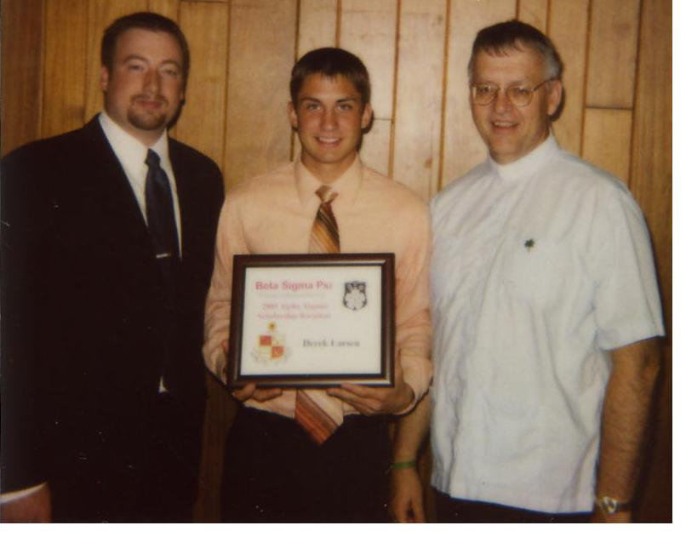
Pictured (L-R): Michael Nolte, Derek Larson, Rev. Karl Otto

(President’s Report - Continued From Page 1)

I realize that not everyone shares the same fondness for Beta Sigma Psi that I do, but I hope that this letter makes you look back and take note of the role that Beta Sigma Psi has played in your life. In past articles, I have suggested, requested, and begged that each of you dedicate resources to the future of Alpha Chapter of Beta Sigma Psi. I have received some response, but it has been extremely minor. For the past two years, the Active and Alumni Chapters have been supported by a very small group of extremely dedicated Alumni. This group of Alumni has performed admirably, but we are in desperate need of assistance. I would like to see Alpha Chapter live on into the future, and I hope that you do as well. All that I am going to do is encourage you to think about the importance of Beta Sigma Psi within your own life, and then act accordingly.

per Aspera, ad Astra
Michael Nolte

Do You Know Someone Coming to the U of I?
If you know someone who will be attending the University of Illinois, please contact Alan Schweizer. I will make sure the information is passed along to the rush chairmen.

Are You Moving?
Please update your mailing address with Alan Schweizer. Each returned newsletter costs about $1. Every little bit helps.

Got Stories?
The Alpha Alumni News is always looking for stories and/or good and welfare. If you have anything to share please send me a letter or an email.

BETA SIGMA PSI – ALPHA CHAPTER
TO THE NEXT 50 YEARS

Enclosed is my donation to the NEXT 50 of $__________

$1000 contributors will receive dinner/dance and game tickets for 2
$500 contributors will receive choice of tickets for 2
$1000 pledges to the house renovation (4 annual payments of $250)
dinner/dance tickets for 2

Name__________________________________________________

Address________________________________________________

City________________ State____

ZIP_______Ph.________________

Graduation year____

Send checks to:
Greg Treichler SPGH
1804 Rita Avenue or to: PO Box 2764
St. Charles, IL 60174 Champaign, IL 61825-2764

*Please note: Beta Sigma Psi with your check when sending checks to SPGH.

The NEXT 50 campaign has been very successful to date with over $11,000 contributed by the alumni membership. Additional contributions of $14,000 are needed to reach our campaign goal of $25,000. Your contribution to the campaign insures the immediate future of Beta Sigma Psi as we embark on a new beginning for the active chapter at the University of Illinois.

A special thank you to all who have contributed to date, your giving is certainly appreciated.

Over the next several months the board of directors hopes to unveil the 80 for 80 campaign that will restart the renovation of the chapter house with a few specific projects including the chapter room and front entry.

